
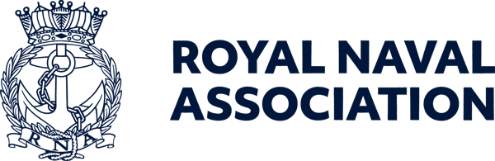

Semaphore Short Friday 14 August 2026

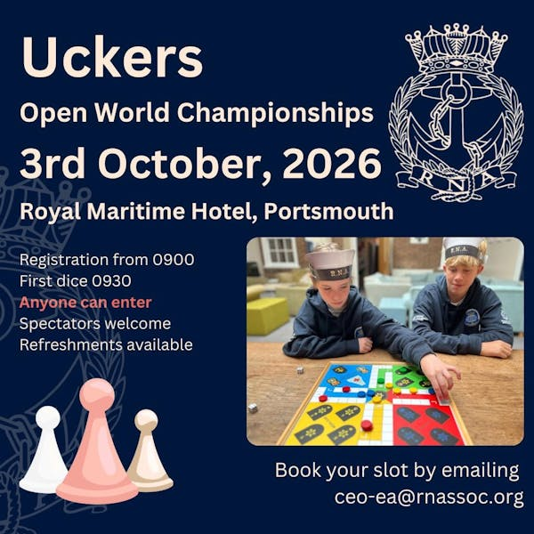

Are you game for a shot at a world title?

There are just 50 days now until the new world champions of Uckers are crowned at the Royal Maritime Hotel in Portsmouth.
Hosted by the Royal Naval Association at the Queen Street venue, just a stone’s throw from the historic dockyard gate, the championship takes place on Saturday 3 October, with registration open from 0900 to 1000.
The first dice are cast at 0930, and even if you are not signing up for the competition, spectators are most welcome to witness the skill and tactical nous on display (with the occasional bit of luck…)
Think you've got what it takes to be crowned Uckers Champion of the World? Whether you're a seasoned veteran of the board or just fancy testing your luck, come and join us for a day packed with dice, drama and full-on matelot mayhem!
You can enter the competition as a solo player or part of a team of two, and we are keen to see ships and establishments represented – you could be playing for the honour of your shipmates.
To help us plan, please register your interest by emailing ceo-ea@rnassoc.org with your name, contact details and whether you're entering solo or with a teammate.

CONA heads to Portsmouth

Before the Uckers world converges on Portsmouth, the Royal Maritime Hotel is also hosting a meeting of CONA – the Conference of Naval Associations – and there is still time for more delegates to join in.
CONA is a forum for representatives of Naval associations across the UK to network, share ideas, strengthen connections and discuss issues of importance to the wider Naval community. The event will be chaired by RNA National President Vice Admiral Duncan Potts.
Whether you are involved with an association, a Branch committee, or simply interested in the organisations that support the wider Naval family, CONA offers an opportunity to meet fellow members, hear from guest speakers and contribute to important discussions.
The gathering is on Friday 11 September between 1300 and 1700, and lunch is included. For more information and to book a place please contact Milly on ceo-ea@rnassoc.org
Please note – delegates qualify for a ten per cent discount when booking a room at the Royal Maritime Hotel if they quote CONA.

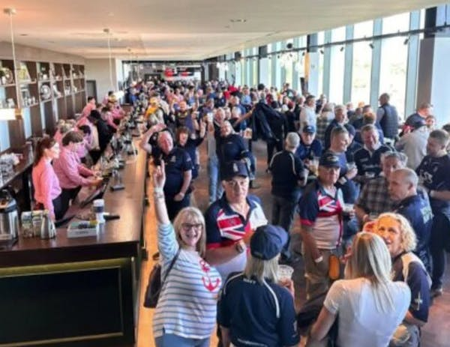

Gunning for a hat-trick

The Royal Navy men’s rugby team are looking for a third victory in a row over the British Army – and you could be there to cheer them on.
So if you’re fretting about Army Navy tickets for Twickenham on Saturday 1 May next year, don't panic, shipmates – we've got you covered. Watch this space!
We're delighted to confirm that the RNA's fantastic Members' Clubhouse Bar will once again be open for members, friends, and family, and tickets will cover both the men’s match at 1400 and the women’s match which follows at 1645.
Even better, we'll have a dedicated RNA seating area, so you'll be able to enjoy the day alongside your fellow shipmates and share the experience as one fleet.
We’re currently finalising ticket arrangements and will be in touch soon with full details on how to secure your tickets through the RNA allocation.
Important: Please hold fire on purchasing tickets directly through the RFU. Those tickets won't form part of the RNA allocation, meaning you could find yourself separated from the rest of the RNA contingent.
Keep an eye on your inbox for further updates. We'll be in touch soon!

  We want your opinion on Conference
  We would still like to hear your views on the 2026 RNA National Conference and Annual General Meeting in Salford last month.
  We are constantly striving to improve the programme for the annual gathering, and organising Branches and Areas welcome the guidance that comes from feedback by delegates, observers and other shipmates who attend Conferences.
  Positive or negative, all comments and suggestions are valuable in giving us an insight into additions (or subtractions!) that could add to the overall experience of shipmates.
  Please fill in our feedback form – use the QR code right or click on this link to a microsoft form.
  



Boost a recruit

Every year, recruits from across the UK and Commonwealth arrive at HMS Raleigh to begin their Royal Navy journey.
For many overseas recruits, leave periods can be particularly challenging as friends head home while they remain far from family and loved ones.
That's what the RNA’s 'Boost a Recruit' campaign is all about – donations help provide simple but meaningful wellbeing activities such as pizza nights, cinema trips, social events and other opportunities for recruits to relax, build friendships and feel supported during their time away from home.
These moments may seem small, but they make a huge difference to morale, resilience and wellbeing.
If you'd like to help our future sailors feel valued and connected, please consider making a donation today.
You can contribute through this link: https://tinyurl.com/2x9he574

Major work ahead – update

Lanyard Building, the home of RNA Central Office in Portsmouth Naval Base, is undergoing an overhaul.
An initial survey has been carried out, and it is estimated that work arising from this will last from mid-September until mid-December. Any further issues that are discovered could lead to a longer period of work.
The Central Office team will be required to relocate to smaller premises for a greater part of this period, which will inevitably lead to some disruption of our normal office routines, but we will do our very best to mitigate against this.
Please watch our social media platforms and communications channels for further details as we get them.



Register for West Country retreat

We have had plenty of interest in our Women's Retreat in the West Country, but we are still inviting expressions of interest for the event, which takes place in Falmouth from 18-20 September.
Delivered in partnership with the Lest We Forget Association, the retreat will bring together women from across the Naval community for a weekend focused on connection, wellbeing, resilience and peer support.
Set on Cornwall’s southern coast, the weekend is expected to include coastal walks, wellbeing workshops, social activities and opportunities to connect with others who understand the unique experiences of Naval life.
Accommodation and meals will be provided for a single contribution of £50 per person.
Places are limited, so if you'd like to attend, we'd love to hear from you as soon as possible.
Register your interest here: https://snra4jc54f7.typeform.com/to/tCg5LiM4

Fly the flag for the Merchant Navy

A reminder that you can show your support for the civilian mariners next month by flying the Red Ensign on Merchant Navy Day – 3 September.
For more details see https://www.theseafarerscharity.org/get-involved/merchant-navy-day

Remembrance Sunday registration

We still have a limited number of places remaining in the RNA contingent which will march along Whitehall in London on Remembrance Sunday, so we are extending the deadline for applications.
Any shipmates interested in marching with the RNA at the November ceremonies in London should register their interest by emailing JB at ams@rnassoc.org no later than 15 September.
Please note – those registering with the RNA will be expected to march with the 140-strong RNA contingent.
In order to march you must possess at least one of the following:
• Veterans Recognition (ID) Card
• Veterans UK Status Card
• Certificate of Service – this must include date of discharge
• Certificate of Discharge
• Veterans Railcard
• For Merchant Mariners – a copy of the personal details page of your Discharge Book, along with the vessel names on which you served and the operation names and date.
Please check the RBL website for eligibility. details: https://www.britishlegion.org.uk/.../remembrance-sunday
Remembrance Sunday this year is 8 November.
Following the Cenotaph parade, the RNA will host a sandwich lunch reception for 50 members (on a first come, first served basis) at the Civil Service Club at 13-15 Great Scotland Yard, London SW1A 2HJ.

Last chance to nominate a veteran

Nominations for this year’s English Veterans Awards close on Monday (August 17).
If you are, or you know of, a veteran who has done some great things since transition to civilian life, or you’re a business/organisation/charity that’s gone above and beyond to support our former military, and they live, work or are based in England, then get in touch!
The final awards ceremony will take place at the De Vere Cotswold Water Park on 1 October.
Categories include Role Model of the Year, the Community Award, Military Charity Fundraiser of the Year, Inspiration of the year and Volunteer of the Year.
For full details and nomination forms see https://veteransawards.co.uk/english-veterans-awards/



Fancy a holiday in the Maldives?

This summer, Royal Navy & Royal Marines Charity is one of the beneficiary charities of the RaiseHero 50/50 Raffle.
Enter from just £5 for your chance to win incredible prizes – including a holiday for two in the Maldives – while helping to support those who serve in the Royal Navy, Royal Marines and Royal Fleet Auxiliary.
The main draw takes place on 30 September, with the prize being a luxury Maldives holiday for two, with white-sand beaches, crystal-clear waters and £10,000 cash to spend. Or you could take home a £20,000 cash alternative.
And if you spend £25 or more and you’ll be entered into a bonus draw to win £1,000 cash.
There are also weekly bonus prizes, so the earlier you enter, the more bonus draws you'll be eligible for:
- Ninja Double Stack air fryer – 19 August
- iPad – 26 August
- Apple smartwatch – 2 September
- Fortnum & Mason hamper – 9 September
- Ninja coffee machine – 15 September
- Nintendo Switch – 22 September
Every entry supports the Royal Navy & Royal Marines Charity, with 50 per cent of tickets purchased helping those who serve, have served, and their families.
For full details of the raffle and rules see https://rnrmc.the5050raffle.com

 |  |  |  |  |  |  |  |  |  |  | 

